Experiment No: 1

Name of the Experiment: I-V Characteristics of diode.

Objective :

Study the I-V characteristic of diode.

Theory :

A diode is a bi-polar device that behaves as the short circuit when it is in forward bias and as an open circuit when it is in reverse bias condition.

Figure 1.1 : Schematic Diagram of Diode. Figure 1.2 : P - N Junction Diode . There are two types of biasing condition for a diode:
1. When the diode is connected across a voltage source with positive polarity of source connected
to p side of diode and negative polarity to n side, then the diode is in forward bias condition.

2. When the diode is connected across a voltage source with positive polarity of source connected to n side of diode and negative polarity to p side, then the diode is in reverse bias condition.

Figure 1.3: Forward Bias connection. Figure 1.4: Reverse Bias connection.

If the input voltage is varied and the current through the diode corresponds to each voltage are taken then the plot of diode current (Id) vs diode voltage (VD) will be follows:
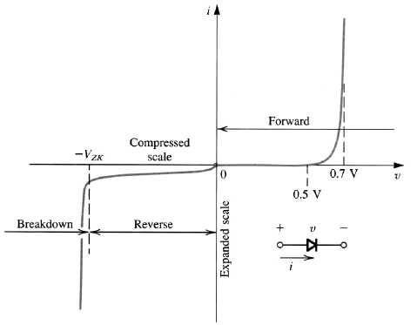

Figure 1.5 : I - V Characteristics of Diode.

At the reverse bias condition the amount of current flows through the diode is very small (at microampere range). But if the voltage continuously increases in reverse direction, at a certain value the diode will break down and huge amount of current will flow in reverse direction. This is called breakdown of diode. In laboratory the breakdown will not tested because it will damages the diode permanently.

From the characteristics curve it can be seen that, a particular forward bias voltage (VT) is required to reach the region of upward swing. This voltage, VT is called the cut-in voltage or threshold voltage of diode. For Si diode the typical value of threshold voltage is 0.7 volt and for Ge diode is 0.3 volt.

Equipments And Components :

Serial no. | Component Details | Specification | Quantity
1. | p-n junction diode | 1N4007 | 1 piece
2. | Resistor | 1KΩ | 1 piece
3. | DC power supply |  | 1 unit
4. | Signal generator |  | 1 unit
5. | Trainer Board |  | 1 unit
6. | Oscilloscope |  | 1 unit
7. | Digital Multimeter |  | 1 unit
8. | Chords and wire |  | as required

Experimental Setup :

+ VR -
+ Ch -

1K

Vd
Vdc

VAC

10 Vp-p 1K
- Ch +
100 Hz

Figure 1.6 : Circuit Diagram for Obtaining Diode Figure 1.7 : Circuit Diagram for Obtaining
Diode Forward Characteristics. Characteristics From Oscilloscope.

Procedure :

1. Measure the resistance accurately using multimeter.
2. Construct the circuit as shown in figure - 1.6.
3. Vary input voltage Vdc. Measure Vdc, Vd, VR for the given values of Vd and record data on data table. Obtain maximum value of Vd without increasing Vdc beyond 25 volt.
4. Calculate the values of Id using the formula, Id = VR / R.
5. Construct the circuit as shown in figure - 1.7.
6. Ste the oscilloscope in X-Y mode. Identify zero record on oscilloscope display. Make proper connection and observe the output.
7. Repeat the step 5 and 6 by increasing the input supply frequency 5 KHz.

Data Table :

Vdc (volt) | Vd (volt) | VR (volt) | Id = VR / R (mA)

Report :

1. Draw the I - V characteristics curve of diode from the reading obtain in this experiment.
2. Calculate static resistance for Id = 5 mA and Id = 10 mA.
3. Determine the Q- point for the circuit in figure - 6, when Vdc = 8 volt.

Experiment No: 02

Name of the Experiment: Diode rectifier circuits.

Objective:

Study of different diode rectifier circuits.

Theory:

A rectifier converts an AC signal into a DC signal. From the characteristic curve of a diode we observe that if allows the current to flow when it is in the forward bias only. In the reverse bias it remains open. So, when an alternating voltage (signal) is applied across a diode it allows only the half cycle (positive half cycle depending on the orientation of diode in the circuit) during its forward bias condition, other half cycle will be clipped off. In the output the load will get DC signal.

Diode rectifier can be categorized in two major types. They are -
1. Half-wave rectifier.
2. Full-wave rectifier.

Half - Wave Rectifier: Half-wave rectifier can be built by using a single diode. The circuit diagram and the wave shapes of the input and output voltage of half wave rectifier are shown bellow (figure 2.1) -

D

+ Vs RL VO
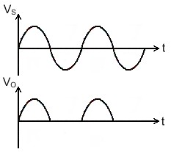-

Figure 2.1: Half Wave Rectifier.

The major disadvantages of half wave rectifier are -
• In this circuit the load receives approximately half of input power.
• Average DC voltage is low.
• Due to the presence of ripple output voltage is not smooth one.
Full Wave Rectifier: in the full-wave rectifier both the half cycle is present in the output. Two circuits are used as full-wave rectifier are shown bellow -
a) Full-wave rectifier using center-tapped transformer.
b) Full-wave bridge rectifier.
Full-wave rectifier using center-tapped transformer: two diodes will be connected to the ends of the transformer and the load will be between the diode and center tap. The circuit diagram and the wave
shapes are shown in bellow (figure 2.2) -

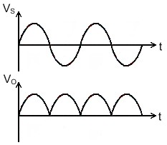D1

Vs 12 V
12 V

12 V
RL

- VO + D2

Figure 2.2: Full Wave Rectifier Using Center Tapped Transformer.

Full-wave rectifier using center-tapped transformer circuit has some advantages over full-wave rectifier. Those are -
• Wastage of power is less.
• Average DC output increase significantly.
• Wave shape becomes smoother.

The disadvantages of full-wave rectifier using center-tapped transformer are -
• Require more space and becomes bulky because of the transformer.
• Not cost effective (for using transformer).

Full-wave bridge rectifier: a bridge rectifier overcomes all the disadvantages of described above. Here four diodes will be connected as bridge connection. The circuit diagram and the wave shapes are shown
in bellow (figure 2.3) -

RL
Vs
- VO +

Figure 2.3: Full Wave Bridge Rectifier.
This rectifier however cannot produce a smooth DC voltage. It produces some ripple in the output. This ripple can be reducing by using filter capacitor across the load.
Equipments And Components:

Serial no. | Component Details | Specification | Quantity
1. | p-n junction diode | 1N4007 | 4 piece
2. | Resistor | 10KΩ | 1 piece
3. | Capacitor | 0.22µF, 10µF | 1 piece each
4. | Signal generator |  | 1 unit
5. | Trainer Board |  | 1 unit
6. | Oscilloscope |  | 1 unit
7. | Digital Multimeter |  | 1 unit
8. | Chords and wire |  | as required

Experimental Setup:

D

+ + D1 D3

10 Vp-p
1 KHz

10 KΩ C VO

-
10 Vp-p
1 KHz

D4 D2
10 KΩ

C VO

-

Figure 2.4 : Experimental Circuit 1. Figure 2.5 : Experimental Circuit 2.

Procedure:

1. Connect the circuit in breadboard as shown in figure 2.4 without capacitor.
2. Observe the output and input voltages in the oscilloscope and draw them.
3. Connect the 0.22µF capacitor and repeat step 2.
4. Connect the 10µF capacitor and repeat step 2. How does the output wave-shape differ from that in step 3?
5. Vary the frequency from 10 KHz to 100 Hz. What effects do you observe when frequency is
changed?
6. Connect the circuit breadboard as shown in figure 2.5 without capacitor.
7. Observe the output and input voltages in the oscilloscope and draw them.
8. Connect the 0.22µF capacitor and repeat step 7.
9. Connect the 10µF capacitor and repeat step 7. How does the output wave-shape differ from that in step 8?
10. Vary the frequency from 10 KHz to 100 Hz. What effects do you observe when frequency is
changed?
Report:
1. Write the answers that were asked during the working procedure.
2. Draw the input wave, output wave (without and with capacitor) for both the circuits.
3. What is the effect in output for changing input signal frequency for both the circuits
(without and with capacitor)?
4. What is the function of capacitor in the both circuits? Why a capacitor of higher value is preferable?

Experiment No: 03

Name of the Experiment: Clipper and Clamper circuits.

Objective:

Study of Clipper and Clamper circuits.

Theory:

Clipper: Clippers remove signal voltage above and below a specified level. In the experiment no. 2, half wave rectifier can also be called as a clipper circuit. Because it clipped off the negative half cycle of the input signal.

A diode connected in series with the load can clipped off any half cycle of input depending on the orientation of the diode. (Figure 3.1) -

D

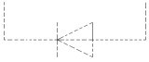+ Vs RL VO
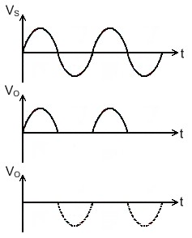-

Figure 3.1: Simple Diode Clipper.

It is also possible to clip off a certain part of the input signal bellow a specified signal level by using a voltage source in reverse bias condition with the diode. If a battery of V volts is added to it, then for Vs above (V+0.7) volts the diode becomes forward bias and turns ON. The load receives above this voltage
level.

V D

+ Vs RL VO
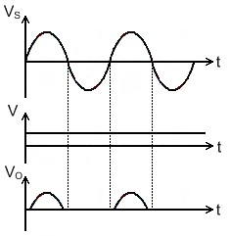-

Figure 3.2: Clipper Circuit Using Bias Diode.
A diode connected in parallel with the load can clip off the input signal above 0.7 volts of one half cycle depending on the connection of the diode. Using two diodes in parallel in opposite direction both the
half cycle can be limited to 0.7 volts.

Vs D
+ RL VO
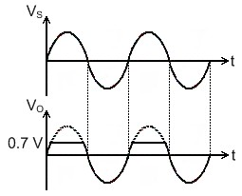-

Figure 3.3: Parallel Clipper Circuit.

Using a biased diode it is possible to limit the output voltage to a specified level depending on the attached battery voltage. Either the half cycles or both of them can be clipped off above a specified level.

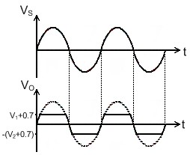D1 D2 + Vs RL VO
-

V2 V1

Figure 3.4: Biased Parallel Clipper Circuit.

In practical case for both the series and parallel clippers voltage source is not added. Required voltage levels are maintained by adding more semiconductor diode.

Clamper: A DC clamper circuit adds a DC voltage to the input signal. For instance, if the incoming signal varies from -10 volts to +10 volts, a positive DC clamper will produce an output that ideally swing from 0 volts to 20 volts and a negative clamper would produce an output between 0 volts to -20 volts.
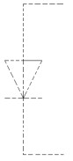C

+ Vs D RL VO
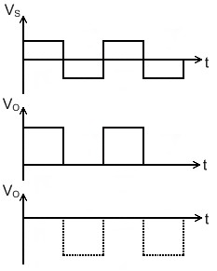-

Figure 3.5: Clamper Circuit.

Equipments And Components :

Serial no. | Component Details | Specification | Quantity
1. | p-n junction diode | 1N4007 | 1 piece
2. | Resistor | 100KΩ | 1 piece
3. | Capacitor | 0.1µF | 1 piece
4. | Signal generator |  | 1 unit
5. | Trainer Board |  | 1 unit
6. | DC power Supply |  | 1 unit
7. | Oscilloscope |  | 1 unit
8. | Digital Multimeter |  | 1 unit
9. | Chords and wire |  | as required

Experimental Setup:

VB VB
D D

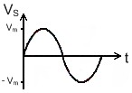Vs 100 KΩ
+
VO Vs
-
+
100 KΩ VO
-

(a) (b)

Figure 3.6: Experimental Circuit 1.
100 KΩ 100 KΩ

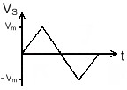D + D + Vs VO Vs VO
VB - VB -

(a) (b)

Figure 3.7: Experimental Circuit 2.

0.1 μF 0.1 μF
D

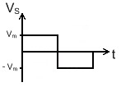Vs 100 KΩ

+
VO Vs
-
VB

D +
100 KΩ VO
-
VB

(a) (b)

Procedure :
Figure 3.8: Experimental Circuit 3.

1. Connect the circuit as shown in the figure 3.6. Using a sinusoidal voltage source with 5 volts peak (Vm).
2. Observe the output wave shapes for various values of VB and draw VB = 2.5 volts for each
circuit..
3. Do the same as in step 1 and 2 for the circuits in figure 3.7 with Vs wave shapes as drawn beside each figure having Vm = 5 volts. Parallel Branch 1 of circuit of figure 3.7(a) and Branch
2 of circuit of figure 3.7(b) and observe output.
4. For the clamper circuits of figure 3.8 do the same steps as step 1 and 2 with Vs wave shapes as drawn beside each figure having Vm = 5 volts.

Report :

1. Sketch all the waveforms observed on the oscilloscope.
2. What role dose the value of capacitor used in the clamping circuit play in order to obtain proper clamping?
3. Add the SPICE simulation waveforms of all the experimental circuits.
Experiment No : 04

Name of the Experiment : Zener Diode applications.

Objective:

Study of the Zener Diode applications.

Theory :

The diodes we have studied before do not operate in the breakdown region because this may damage them. A Zener diode is different; it is a silicon diode that the manufacturer has optimized for operation in the breakdown region. It is used to build voltage regulator circuits that circuits that hold the load voltage almost constant despite large change in line voltage and load resistance. The symbol of Zener diode shows in figure 4.1.

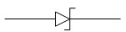

Figure 4.1 : Symbol of Zener Diode.

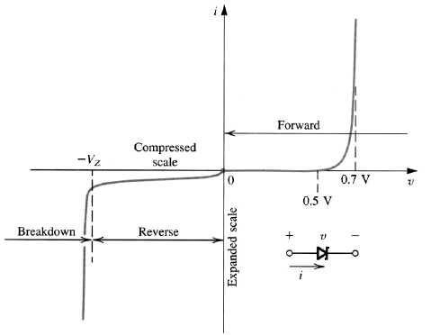

Figure 4.2 : I - V Characteristics of Zener Diode.

The Zener diode may have a breakdown voltage from about 2 to 200 volts. These diodes can operate in any of three regions – forward, leakage and breakdown. Figure 4.2 shows the I-V characteristics curve of Zener diode.

• In the forward region it works as an ordinary diode.
• In the leakage region (between zero and breakdown) it has only a small reverse saturation current.
• In the breakdown it has a sharp knee, followed by an almost vertical increase in current without changing the voltage.
• The voltage is almost constant, approximately equal to Vz over most of the breakdown region.
Equivalent circuits of Zener Diode : Two approximation are used for Zener Diode equivalent circuit.

First Approximation : As the voltage remains constant across the Zener diode though the current changes through it, it is considered as a constant voltage source according to the first approximation.

= VZ

Second Approximation : A Zener resistance is in series with the ideal voltage source is approximated.

RZ
=
VZ

Equipments and Components:

Serial no. | Component Details | Specification | Quantity
1. | Zener diode | 5 volts | 1 piece
2. | Resistor | 220Ω, 470Ω, 1KΩ | 1 piece each
3. | POT | 10KΩ | 1 unit
4. | Trainer Board |  | 1 unit
5. | DC Power Supply |  | 1 unit
6. | Digital Multimeter |  | 1 unit
7. | Chords and wire |  | as required

Experimental Setup:

470 Ω

+

VZ V

-

470 Ω

220 Ω

VL

10 KΩ

Figure 4.3 : Experimental Circuit 1. Figure 4.4 : Experimental Circuit 2.

Procedure :

1. Connect the circuit as shown in the figure 4.3
2. Vary the supply voltage from zero volt, complete the Table 4.1.
3. Connect the circuit as shown in the figure 4.4
4. Keep the POT at maximum position and power up the circuit. Apply 10 as V.
5. Gradually decrease the POT resistance and complete the Table 4.2.
6. Replace load with 1KΩ resistance, vary the supply voltage and take reading for Table 4.3.

Table 4.1 : Data for I - V characteristics.

V (volts) | VR (volts) | Vz (volts) | Iz = VR / R  (mA)
1.0
2.0
3.0
4.0
5.0
6.0
7.0
8.0
9.0
10.0
11.0
12.0

Table 4.2 : Data for regulation due to load variation.

V220 (mV) | VL (volts) | IL (Amp)

Table 4.3 : Data for regulation due supply voltage variation.

V (volts) | VL (volts)
5.0
6.0
7.0
8.0
9.0
10.0
11.0
12.0

Report :

1. Plot the I - V characteristics of Zener diode. Determine the Zener breakdown voltage from the plot.
2. Plot IL vs VL for the data table 4.2. Find the voltage regulation.
3. Plot VL vs V for the data table 4.3. Find the voltage regulation.
Experiment No: 05

Name of the Experiment: The BJT Biasing Circuits.

Objective:

Study of the BJT Biasing Circuits.

Theory :

Unlike the diode, which has two doped region, a transistor has three doped region. They are as follows –
a) Emitter, b) Base and c) Collector.

These three doped regions form two junctions: One between the emitter and base and other between the collector and the base. Because of these it can be thought as combination of two diodes, the emitter and the base form one diode and the collector and base form another diode. The emitter is heavily doped. Its job is to emit or inject free majority carrier (electron for NPN and hole for PNP) into the base. The base is lightly doped and very thin. It passes the most of the emitter-injected electron (for NPN) into the collector. The doping level of the collector is between emitter and base. Figure 5.1 shows the biased NPN transistor.

RC

VBB
+ RB
VCE
+
-
VBE

-

VCC

Figure 5.1 : Biasing of an NPN transistor.

If the VBB is greater than the barrier potential, emitter electron will enter base region. The free electron can flow either into the base or into the collector. As base lightly doped and thin, most of the free electron will enter into the collector.
There are three different current in a transistor. They are emitter current (IE), collector current (IC) and the base current (IB) are shows in figure 5.2.

IC

IB

IE

Figure 5.2 : Different current in transistor.

Here, IE = IC + IB, and the current gain β = | IC
 | IB

Characteristics Curve : The characteristics of a transistor is measured by two characteristics curve. They are as follows –
a) Input characteristics curve.
b) Output characteristics curve.

Input Characteristics Curve : Input characteristics is defined as the set of curves between input current (IB) vs. input voltage (VBE) for the constant output voltage (VCE). It is the same curve that is found for a forward biased diode.
Output Characteristics Curve : Output characteristics is defined by the set of curves between output current (IC) vs. output voltage (VCE) for the constant input current (IB). The curve has the following features –
• It has three regions namely Saturation, Active and Cutoff region.
• The rising part of the curve, where VCE is between 0 and approximately 1 volt is called saturation region. In this region the collector diode is not reversed biased.
• When the collector diode of the transistor becomes reverse biased, the graph becomes horizontal. In this region the collector remains almost constant. This region is known as the active region. In applications where the transistor amplifies weak radio and TV signal, it will always be operation in the active region.
• When the base current is zero, but there is some collector current. This region of the transistor curve is known as the cutoff region. The small collector current is called collector cutoff current.
• For different value of base current (IB) an individual curve can be obtained.

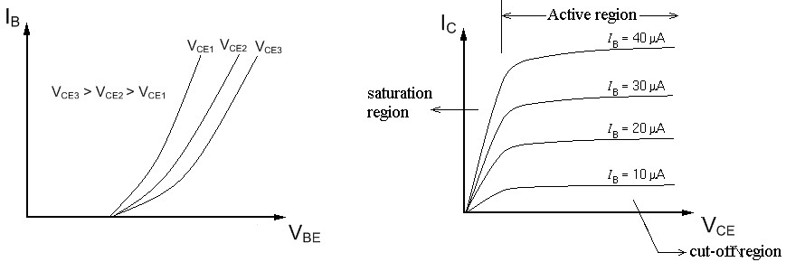Figure 5.3 : (a) Input Characteristic, (b) Output Characteristic of NPN transistor.
Biasing a BJT circuit means to provide appropriate direct potentials and currents, using external sources, to establish an operating point or Q-point in the active region. Once the Q-point is established, the time varying excursions of input signal should cause an output signal of same waveform. If the output signal is not a faithful reproduction of the input signal, for example, if it is clipped on one side, the operating point is unsatisfactory and should be relocated on the collector characteristics. Therefore, the main objective of biasing a BJT circuit is to choose the proper Q-point for faithful reproduction of the input signal. There are different types of biasing circuit. However, in the laboratory, we will study only the fixed bias and self bias circuit. In the fixed bias circuit, shown if figure 5.4, the base current IB is determined by the base resistance RB and it remains constant. The main drawback of this circuit is the instability of Q-point with the variation of β of the transistor. In the laboratory, we will test the stability using two transistors with different β. In the self bias circuit shown if figure 5.5, this problem is overcome by using the self biasing resistor RE to the emitter terminal.

Equipments And Components :

Serial no. | Component Details | Specification | Quantity
1. | NPN Transistor | C828, BD135 | 1 piece each
2. | Resistor | 470Ω, 560Ω, 220KΩ, 10 KΩ | 1 piece each
3. | POT | 10KΩ, 100 KΩ | 1 unit
4. | Bread Board |  | 1 unit
5. | DC Power Supply |  | 1 unit
6. | Digital Multimeter |  | 1 unit
7. | Chords and wire |  | as required

Experimental Setup:

RB 100 KΩ
RC 470 Ω

10V
220 KΩ

Figure 5.4: Experimental Circuit 1.

RB1
10 KΩ RC
470 Ω

10 V

RB2
10 KΩ
560 Ω

Procedure:
Figure 5.5: Experimental Circuit 2.

1. Arrange the circuit shown in figure – 5.4 by C828. Record RC and set RB to maximum value.
2. Decrease POT RB gradually so that VCE = VCC / 2.
3. Measure voltage across RC and VCE.
4. Record the Q-point (VCE, IC).
5. Replace the C828 transistor by BD135 and repeat step 3 and 4.
6. Arrange the circuit shown in figure – 5.5 by C828. Record RC and set RB to minimum value.
7. Increase POT RB2 gradually so that VCE = VCC / 2.
8. Measure voltage across RC and VCE.
9. Record the Q-point (VCE, IC).
10. Replace the C828 transistor by BD135 and repeat step 8 and 9.
Data Sheet :

Table 5.1 : Data for Fixed Bias Circuit.

Transistor | RC  (Ω) | VC  (volt) | IC = VC / RC  (Amp) | VCE  (volt) | Q-point
C828
BD135

Table 5.2 : Data for Self Bias Circuit.

Transistor | RC  (Ω) | VC  (volt) | IC = VC / RC  (Amp) | VCE  (volt) | Q-point
C828
BD135

Report:

1. Which circuit shows better stability? Explain in the context of the results obtained in the laboratory.
2. Draw the DC load line for both the circuits and show the Q-point.
Experiment No: 06

Name of the Experiment: Study of Switching Characteristics

Introduction:

The most common transistor types are the Metal Oxide Semiconductor Field Effect Transistors (MOSFETs) and the Bipolar Junction Transistors (BJT). BJTs based circuits dominated the electronics market in the 1960's and 1970's. Nowadays most electronic circuits, particularly integrated circuits (ICs), are made of MOSFETs. The BJTs are mainly used for specific applications like analog circuits (e.g. amplifiers), high-speed circuits or power electronics.

There are two main differences between BJTs and FETs. The first is that FETs are charge- controlled devices while BJTs are current or voltage controlled devices. The second difference is that the input impedance of the FETs is very high while that of BJT is relatively low.

As for the FET transistors, there are two main types: the junction field-effect transistor (JFET) and the metal oxide semiconductor field effect transistor (MOSFET). The power dissipation of a JFET is high in comparison to MOSFETs. Therefore, JFETs are less important if it comes to the realization of ICs, where transistors are densely packed. The power dissipation of a JFET based circuit would be simply too high. The combination of n- type and p-type MOSFETs allow for the realization of the Complementary Metal Oxide Semiconductor (CMOS) technology, which is nowadays the most important technology in electronics. All microprocessors and memory products are based on CMOS technology. The very low power dissipation of CMOS circuits allows for the integration of millions of transistors on a single chip. In this experiment, we will concentrate on the MOSFET transistor. We will investigate its characteristics and study its behavior when used as a switch.

Theory:

MOSFETs Structure and Physical Operation

The MOSFETs are the most widely used FETs. Strictly speaking, MOSFET devices belong to the group of Insulated Gate Field Effect Transistor (IGFETs). As the name implies, the gate is insulated from the channel by an insulator. In most of the cases, the insu lator is formed by a silicon dioxide (SiO2), which leads to the term MOSFET. MOSET like all other IGFETs has three terminals, which are called Gate (G), Source (S), and Drain (D). In certain cases, the transistors have a fourth terminal, which is called the bulk or the body terminal. In PMOS, the body terminal is held at the most positive voltage in the circuit and in NMOS, it is held at the most negative voltage in the circuit.
There are four types of MOSFETs: enhancement n-type MOSFET, enhancement p-type MOSFET, depletion n-type MOSFET, and depletion p-type MOSFET. The type depends whether the channel between the drain and source is an induced channel or the channel is physically implemented and whether the current owing in the channel is an electron current or a hole current.
The cross section of an enhancement NMOS transistor is shown in figure below. If we put the
drain and source on ground potential and apply a positive voltage to the gate, the free holes
(positive charges) are repelled from the

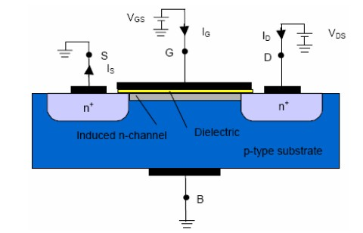

Schematic cross section of an enhancement type NMOS transistor
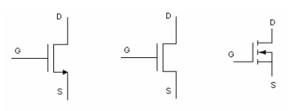
Symbols for Enhancement NMOS Transistor

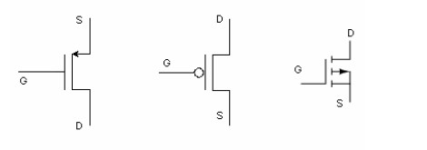
Symbols for Enhancement PMOS Transistor

region of the substrate under the gate (channel region) due to the positive voltage applied to the gate. The holes are pushed away downwards into the substrate leaving behind a depletion region. At the same time, the positive gate voltage attracts electrons into the channel region.
When the concentration of electrons near the surface of the substrate under the gate is higher than the concentration of holes, an n region is created, connecting the source and the drain regions. The induced n-region thus forms the channel for current flow from drain to source. The channel is only a few nanometers wide. Nevertheless, the entire current transport occurs in this thin channel between drain and source.

A common application of MOSFETs is switches in analog and digital circuits.
Switches in analog circuits can be used for example in data acquisition systems, where they
serve as analog multiplexors, which allow the selection of one of several data inputs.

A simple example of a switching circuit based on an n-type enhancement transistor and a
resistor is shown below. The voltage applied to the gate controls the conductance of the channel. A zero or low value of VGS, the conductance is very low so that is the transistor acts like an open circuit and no current flows through the load resistor RL. When VGS exceeds the threshold, the channel conductance becomes higher and the transistor acts like a closed switch. The channel resistance is not getting zero but the resistance is getting small so that the output voltage Vout is getting small. Fig.6.1(a) below shows an NMOS switching FET and its models for Vin = 0 (Fig. (b)) and Vin = +5V (Fig. (c)). In each case, the FET is modeled as a mechanical switch.

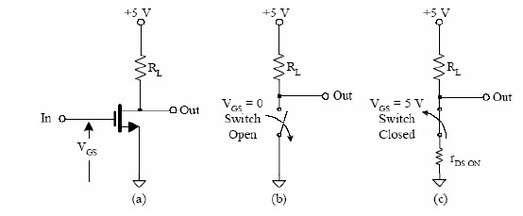
Fig: 6.1 NMOS transistor switch

As for PMOS, a negative value of VGS has to be applied to turn the transistor on. The operation can be described using the curves shown in figure below. When the input voltage, VGS, of the transistor shown is zero, the MOSFET conducts virtually no current, and the output voltage, Vout, is equal to VDD. When VGS is equal to 5V , the MOSFET Q-point moves from point A to point B along the load line, with VDS = 0.5V . Thus, the circuit acts as an inverter. The inverter forms the basis of all MOS logic gates.

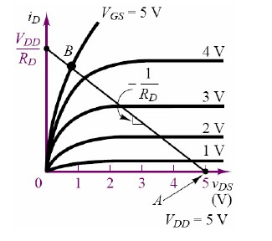

Fig: 6.2 MOSFET switching characteristics

Equipments And Components :

Serial no. | Component Details | Specification | Quantity
1. | MOSFET | IRF540 | 1 piece each
2. | Resistor | 1KΩ | 1 piece each
3. | POT |  | 1 unit
4. | Trainer Board |  | 1 unit
5. | DC Power Supply |  | 2 unit
6. | Digital Multimeter |  | 1 unit
7. | Chords and wire |  | as required

Experimental Setup(Fig.6.3):
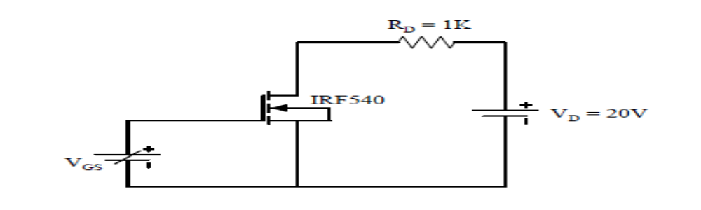

Fig.6.3
Procedure:
1. Set VGS to zero and record the VDS, VL and ID.
2. Increase the gate voltage VGS gradually and record the readings.
3. Take reading until ID = 20mA (or the saturation current of the MOSFET).
4. Note the condition of VDS and ID of steps 1 and 3.
5. Repeat the experiment for VDD = 15 Volts.

VDD = 15V |  |  |  | VDD = 20V
VGS | VDS | VL | ID | VGS | VDS | VL | ID

Report: Describe the circuit operation using experimental data

Experiment 07:
Name of the Experiment: MOSFET Amplifier
Objective : Become familiar with the MOSFET amplifier.

Theory:
MOSFET is a three terminal electronic device. It is a voltage controlled device. There are two types of MOSFET : 1) Depletion type MOSFET and 2) Enhancement type MOSFET. IRF 540 is the n-channel enhancement type MOSFET. The symbol of this MOSFET is shown in Fig.1


Fig.1 n-channel enhancement-type
MOSFET

The terminals of MOSFET are: Gate (G), Drain (D), and Source (S). For an n-channel Enhancement-type MOSFET when gate to source voltage, V_{GS}> V_{th} the drain current, I_{D} is related to the V_{GS} by the following equation:

$$I_{D}=k{\left(V_{GS}-V_{th}\right)}^{2}$$
where
$I_{D}$ is the drain current.
The $V_{GS}$ is the Gate to Source Voltage.
The $V_{th}$ is the threshold voltage at which the MOSFET turns on
$k$ is the transconductance parameter which solely depends on the type MOSFET being used.

Biasing Techniques
To set a proper operating point (Q-point) for MOSFET circuits, several biasing techniques are used. Here voltage divider biasing is discussed.
Voltage Divider Biasing Circuit: The circuit given in Fig.2, shows how the voltage divider circuit works. What this circuit does is that since $I_{G}=0 A$, it takes the voltage $V_{DD}$ and divides it amongst $R_{1}$ and $R_{2}$, thus, using Voltage Divider Rule, the gate voltage $\left(V_{G}\right)$ applied will be equal to

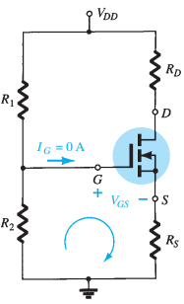
the voltage across $R_{2}$.
$$V_{G}=\frac{R_{2}}{R_{1}+R_{2}}V_{DD}$$
Using KVL in the given loop in Figure 7.3, we can get the following equation:
$$V_{GS}=V_{G}-I_{D}R_{S}$$
Recall that drain current $\left(I_{D}\right)$ flowing through $R_{D}$ and $R_{S}$ are the same.
Fig.2

Transfer Curve
The Transfer Curve for an n-type MOSFET can be found using Shockley’s equation, the graph in Fig.3 shows a sudden exponential increase of drain current when the gate-to-source voltage applied is greater than the threshold voltage $\left(V_{GS}>V_{th}\right)$.
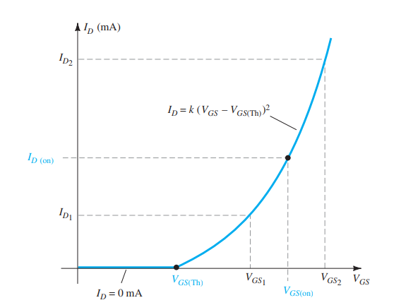
Fig.3
This curve is obtained after knowing the parameter $k$, which can be found using the equation:
$$k=\frac{I_{D(on)}}{{\left(V_{GS\left(on\right)}-V_{th}\right)}^{2}}$$The drain current and gate voltages needed to calculate $k$, are taken from the data sheet of the MOSFET being used.

Equipment and Component:

Serial no. | Component Details | Specifications | Quantity
1 | MOSFET | IRF540n | 1 piece
2 | Resistor | 1kΩ, 3.3kΩ, 200kΩ, 220kΩ | 1 piece each
3 | Capacitors | 0.01 uF | 2 pieces
4 | Function Generator Oscilloscope |  | 1 unit  1unit
5 | DC Power Supply |  | 1 unit
6 | Digital Multimeter |  | 1 unit
7 | Chords and Wires |  | 1 unit

Experimental Circuit Diagram:

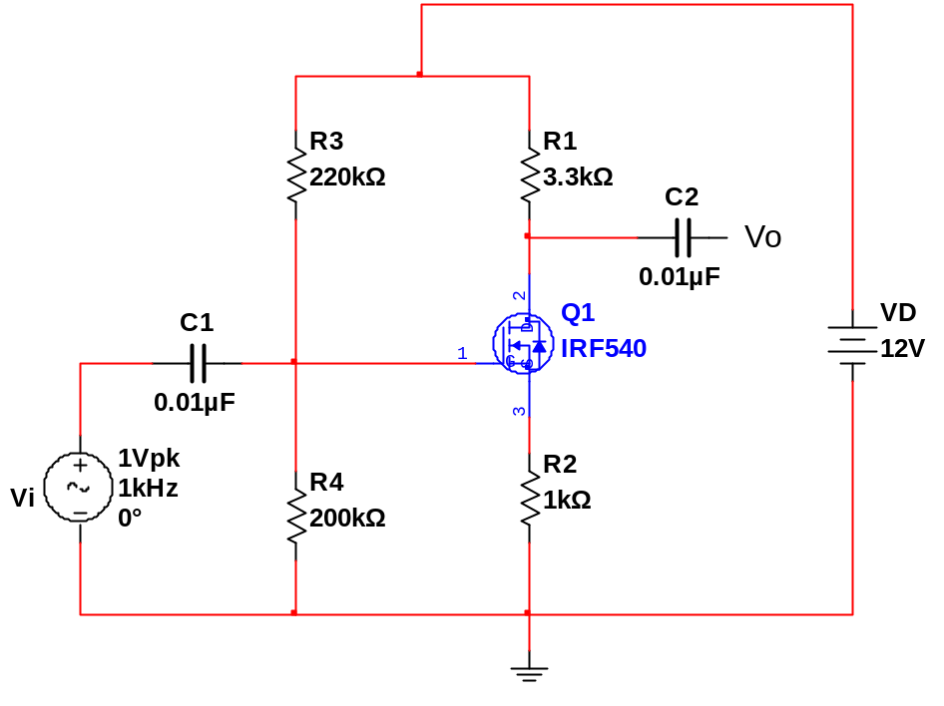
V_{OUT}

V_{DD}=5V

Procedure:
- Implement the circuit on the bread board
- Connect the channels(CH-1 and CH-2) of the oscilloscope with input and output terminals
- Set the input voltage Vi=1Vpk and frequency = 1KHz by using Function generator.
- Observe the input and output signals on the oscilloscope screen. If faithful output is found, measure V_{i} , Vo and phase difference.
- Calculate the voltage gain.

Simulation:
By simulating the experimental circuit collect the value of Vi and Vo. Calculate voltage gain and copare the result with practical data.

